# How to trigger a jenkins job when code is pushed to github using “GitHub hook trigger for GITScm polling”

The GitHub plugin for Jenkins is the most basic plugin for integrating Jenkins with GitHub projects. If you are a GitHub user, this plugin enables you to:

* Schedule your build
* Pull your code and data files from your GitHub repository to your Jenkins machine
* Automatically trigger each build on the Jenkins server, after each Commit on your Git repository

This saves you time and lets you incorporate your project into the Continuous Integration (CI) process.

Our Jenkins application will build and test the changes and send the build status for the commit that was made.

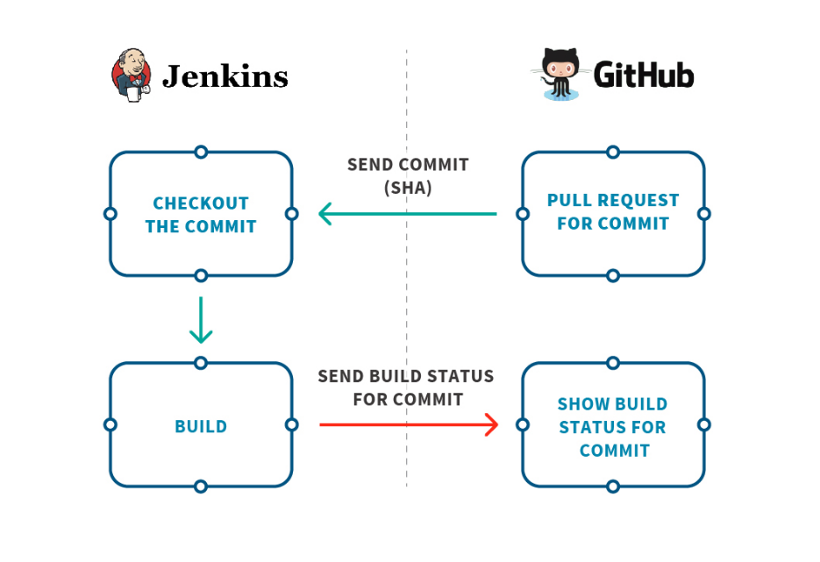

## **GitHub Integration Plugin**

You need to install a special plugin for Jenkins called “GitHub Integration”.

Follow these steps,

1. Go to Manage Jenkins > Manage Plugins > Available.
2. Use the search bar and search for “GitHub”.
3. Search and select the plugin named “[GitHub Integration](https://plugins.jenkins.io/github-pullrequest)”.
4. Click on “Download now and Install after Restart”.

## **Setup**

Follow these steps to create a job (if you haven’t already),  
Check the “**Github project**” checkbox and place your Github repository URL link.

1 – Check the “Github project” checkbox and place your Github repository URL link.

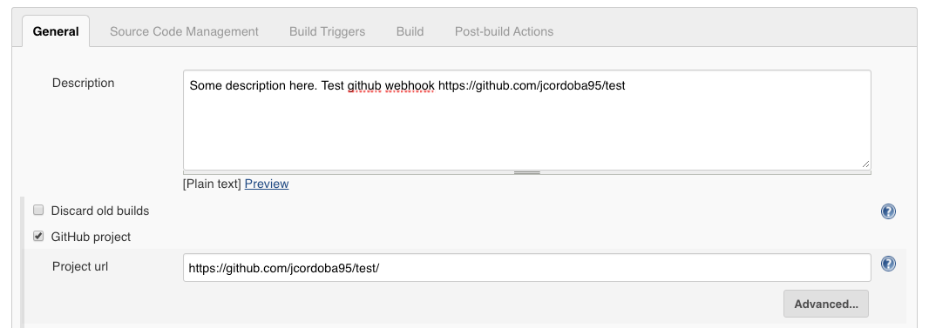

2 – Under the **Source Code Management** section we select “git” and place our repository URL once again.

3 – Specify which branches you want to build. By default Jenkins will select the master branch for you.

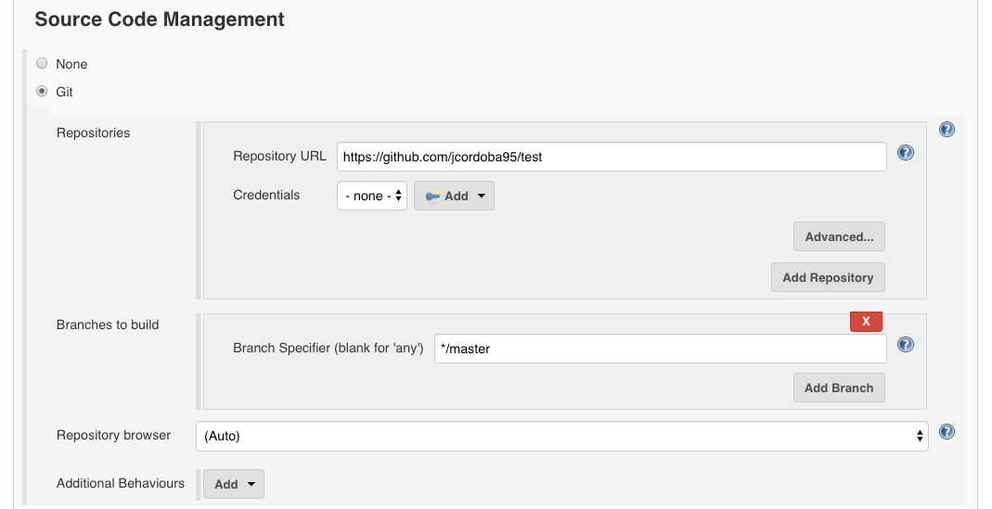

4 – Now you can select your build triggers. The Github Integration plugin will add the “**Github hook trigger for GITScm polling**” option for you. Which means that every time Jenkins receives a PUSH GitHub hook (from the repository you defined in the Source Code Management section) it will trigger the polling login you previously defined.

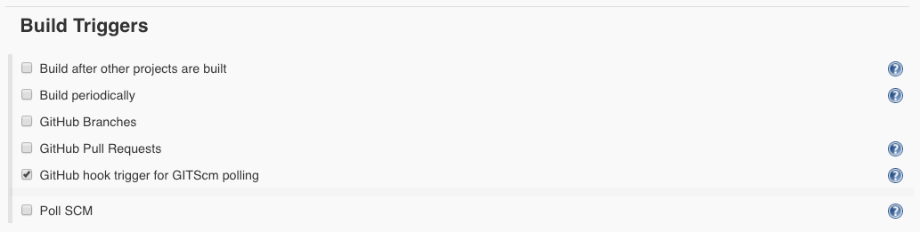

After all that, just let GitHub know that it has to notify your Jenkins server every time there is a commit.To do this, go to **GitHub repository > settings > Webhooks > Add webhook**

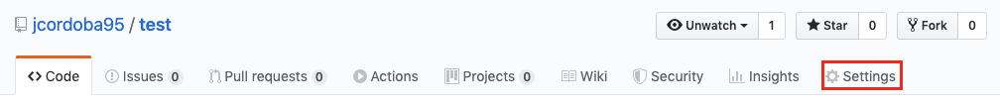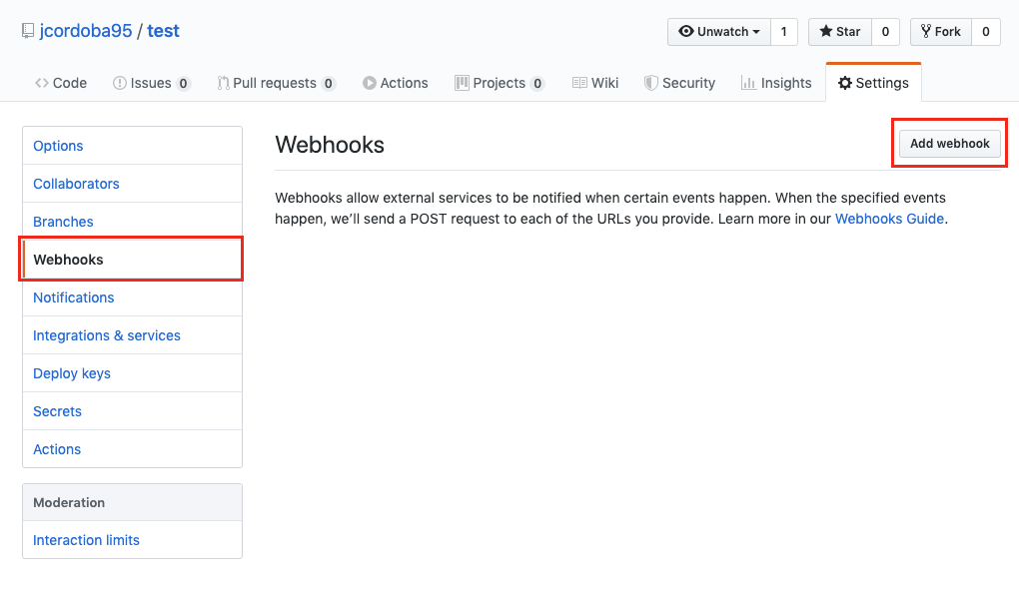

Then fill the following information,

1 – In Payload URL place the Jenkins server URL with this format: “**<PAYLOAD_URL>/github-webhook/**”. Just by appending this “/github-webhook/” you are telling Jenkins to route the request to the GitHub plugin.

2 – Select the **content type**.

3 – Configure when GitHub should send events to this webhook.

4 – Check the “Active” box.

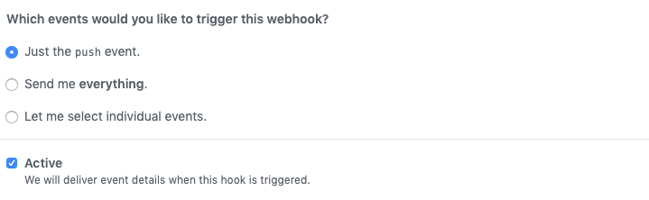

And you are done! Your Jenkins server will build according to how you configured the GitHub webhook. Any questions or comments send me a line at jcordoba@nearsoft.com.

